GITHUB LINK : https://github.com/Sujal-Khera/Agricultural-Advisory-System
50% Implementation Report
Agricultural Advisory System
1. Introduction
Agriculture plays a crucial role in sustaining economies and ensuring food security. However, farmers often face challenges such as selecting the right crop, identifying plant diseases early, and understanding environmental conditions. These decisions require access to expert knowledge, which is not always available, especially in rural areas.
Traditional agricultural advisory systems are limited in scope and often provide fragmented solutions. Some systems provide crop recommendations, while others focus only on disease detection. Very few systems combine multiple AI based solutions into a single platform. Furthermore, many existing solutions lack real time intelligence, multimodal interaction, and persistent data storage.
To address these limitations, the Intelligent Multimodal Agricultural Advisory System is being developed. This system integrates machine learning models, APIs, and database storage to provide comprehensive agricultural advice. The system is designed to handle crop recommendation, disease detection, weather based analysis, and conversational advisory.
At the current stage, the backend system has been successfully implemented. This includes machine learning model training, API development, database integration, and inference pipeline creation. The frontend and advanced advisory features are planned for the next phase.
This document presents the fifty percent implementation of the project, focusing on backend development and model integration.

2. Problem Statement
Farmers often face difficulties in making informed agricultural decisions due to lack of access to timely and reliable information. Selecting the right crop depends on soil conditions, weather patterns, and environmental factors. Without proper knowledge, farmers may choose unsuitable crops, leading to reduced yield and financial loss.
Another major challenge is plant disease detection. Farmers often identify diseases at a late stage, when the damage is already significant. Early detection is essential to prevent crop loss, but expert consultation is not always available in remote areas.
Existing agricultural advisory systems are often fragmented and do not provide integrated solutions. Crop recommendation systems operate independently from disease detection systems. Weather data is not always incorporated into decision making. As a result, farmers must rely on multiple tools and platforms.
Additionally, many existing systems do not store historical data. Without historical information, it becomes difficult to track crop performance and improve future recommendations.
Therefore, there is a need for an intelligent agricultural advisory system that integrates crop recommendation, disease detection, weather analysis, and advisory generation into a unified platform.
The Intelligent Multimodal Agricultural Advisory System aims to solve these challenges by providing AI driven recommendations using machine learning models and real time data.

3. Objectives
The primary objective of this project is to develop an intelligent agricultural advisory system that provides accurate and timely recommendations to farmers. The system aims to combine multiple artificial intelligence components into a single platform.
One of the main objectives is to implement a crop recommendation system that predicts the best crop based on soil and environmental parameters. This helps farmers select suitable crops and improve productivity.
Another objective is to implement a plant disease detection system using deep learning. This system identifies plant diseases using leaf images and provides early diagnosis.
The project also aims to integrate external APIs to fetch weather and soil data. This information improves prediction accuracy and enhances advisory recommendations.
Another objective is to implement a backend system that handles machine learning inference, API communication, and database storage. The backend architecture is designed to be scalable and modular.
The project also aims to store prediction results and user data in a database. This allows tracking of user history and improves future recommendations.
At the current stage, the objective is to complete backend implementation including model training, API development, and database integration. The frontend interface and advanced advisory features will be implemented in the next phase.

4. Methodology / Approach
The system follows a modular machine learning based approach. The methodology involves data collection, model training, backend development, API integration, and database persistence.
The first step in the methodology is dataset collection. The crop recommendation dataset includes soil parameters such as nitrogen, phosphorus, potassium, temperature, humidity, pH value, and rainfall. The plant disease dataset includes leaf images for different crops and diseases.
After dataset collection, preprocessing is performed. The crop dataset is cleaned and normalized. The image dataset is resized and augmented for training.
The next step involves model training. The crop recommendation model is trained using Random Forest algorithm. The disease detection model is trained using convolutional neural network architecture.
After training, the models are saved and integrated into backend services. The backend is developed using FastAPI and Python.
API endpoints are created for crop recommendation and disease detection. These endpoints accept user input and return predictions.
External APIs such as OpenWeather and SoilGrids are integrated into the backend. These APIs provide environmental data.
Supabase database is configured for storing user data and prediction results. Database tables are created for storing history and user information.
The backend system is then tested using API testing tools. Predictions are verified and database integration is validated.
This methodology ensures modular development and scalable architecture.

5. Backend System Overview
The backend of the Intelligent Multimodal Agricultural Advisory System is designed as a modular microservice based architecture. The backend handles machine learning inference, data processing, API communication, and database persistence.
The backend system is implemented using Python and FastAPI. FastAPI was selected due to its asynchronous capabilities, fast response time, and easy integration with machine learning models. The backend is structured into multiple service modules including crop recommendation service, disease detection service, weather service, Gemini advisory service, and Supabase service.
The backend architecture is divided into separate directories including API routes, model services, utility functions, and configuration files. This modular design ensures scalability and maintainability of the system.
The backend system includes the following implemented modules:
- Crop Recommendation Model
- Plant Disease Detection Model
- Weather Data Fetching Service
- Gemini Advisory Service
- Supabase Database Integration
- API Endpoints for Model Inference
These components collectively form the core backend infrastructure of the agricultural advisory system.
6. Machine Learning Model Implementation
The backend implementation includes two major machine learning models. These models form the core intelligence of the agricultural advisory system.
6.1 Crop Recommendation Model
The crop recommendation system is implemented using a Random Forest classification algorithm. The goal of this model is to predict the most suitable crop based on soil parameters and environmental conditions.
The dataset used for crop recommendation includes parameters such as nitrogen, phosphorus, potassium, temperature, humidity, pH value, and rainfall. These parameters are commonly used in agricultural research for crop suitability prediction.
The Random Forest model was selected because it performs well on tabular datasets and handles non linear relationships effectively. Random Forest also provides high accuracy and robustness against noisy data.
The training process involved loading the dataset, performing preprocessing, splitting the dataset into training and testing sets, and training the Random Forest model. After training, the model was evaluated using accuracy metrics.
The trained model was serialized using pickle and stored for inference. During runtime, the model is loaded once and used for prediction through API endpoints.
The crop recommendation model takes input parameters such as nitrogen, phosphorus, potassium, temperature, humidity, rainfall, and pH value. Based on these inputs, the model predicts the most suitable crop.
This model is integrated into the backend API and is accessible through a dedicated endpoint.
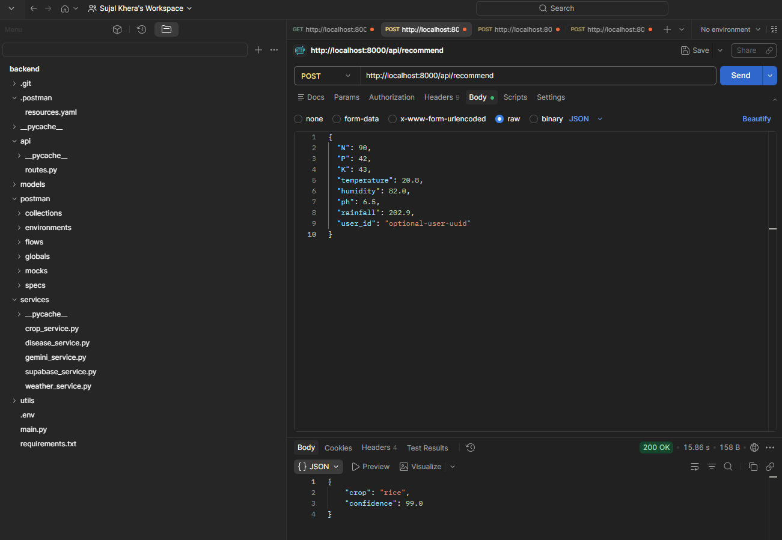
6.2 Plant Disease Detection Model
The plant disease detection system is implemented using a convolutional neural network model. The model is trained using leaf image datasets to detect plant diseases.
The dataset used for training is derived from PlantVillage dataset. This dataset contains multiple crop types and disease classes. Images were preprocessed by resizing, normalization, and augmentation.
The model architecture is based on transfer learning using a pretrained convolutional neural network. Transfer learning was used to improve accuracy and reduce training time.
The training pipeline included image preprocessing, model training, validation, and saving the trained model weights. After training, the model was exported and loaded into the backend inference service.
The inference pipeline includes image upload, image preprocessing, model prediction, and result generation. The model returns disease name along with prediction confidence.
The disease detection API accepts image input and user identifier. The backend processes the image and returns prediction results.
The following screenshot shows the working API endpoint for disease detection and model prediction.
The system successfully detected "American Bollworm on Cotton" with high confidence using the trained model.
This confirms successful implementation of the disease detection pipeline.
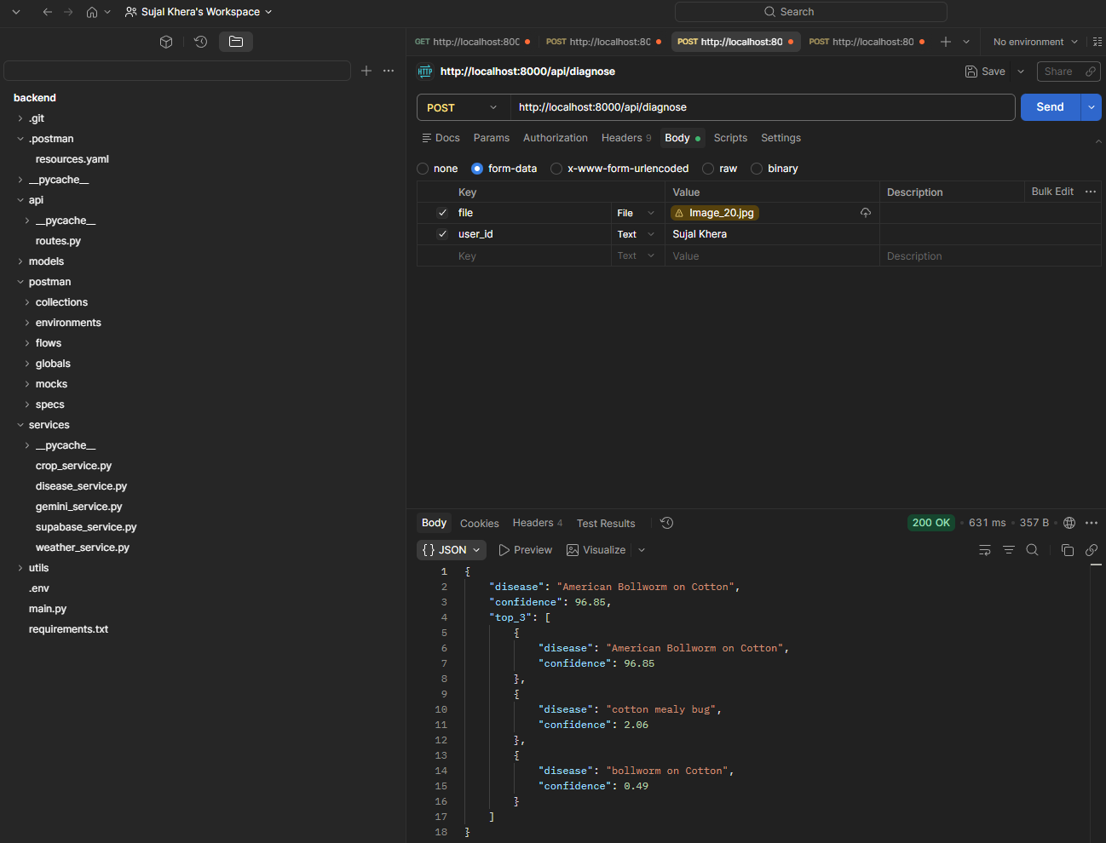
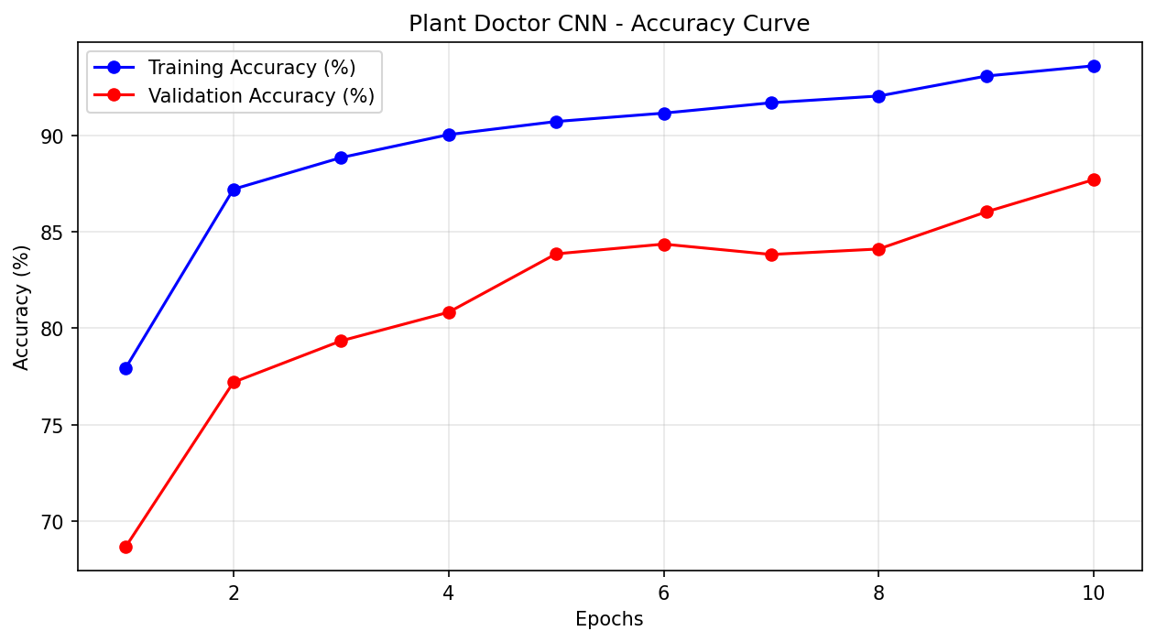
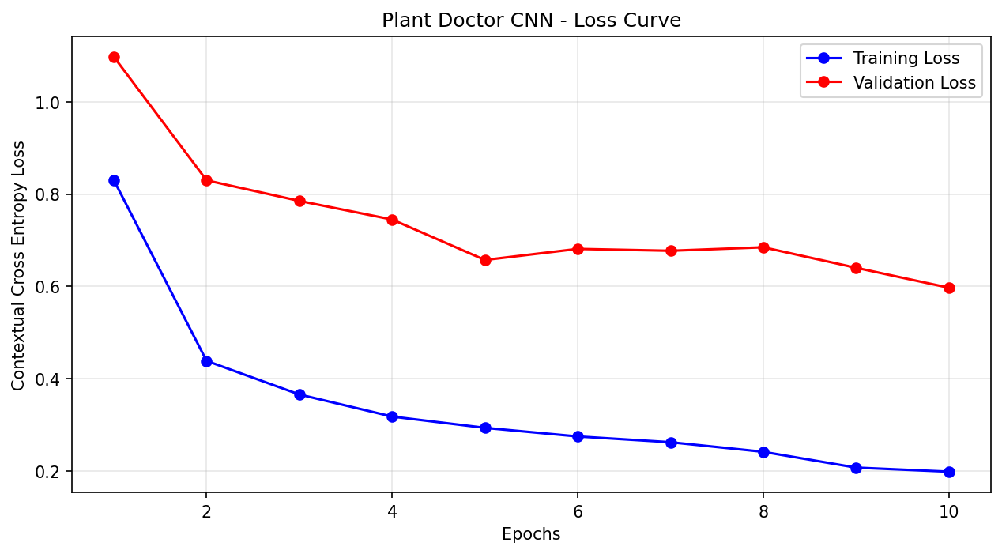

7. Backend API Implementation
The backend APIs are implemented using FastAPI. These APIs allow communication between frontend and backend services.
The main API endpoints implemented include diagnosis endpoint, crop recommendation endpoint, and advisory endpoint.
The diagnosis API accepts image input and user identifier. The image is processed by the disease detection model and prediction results are returned.
The API accepts multipart form data including image file and user ID. After receiving the request, the backend processes the image and sends it to the CNN model.
The API returns JSON response containing disease name, confidence score, and top predictions.
The backend successfully processed API requests and returned predictions. This confirms that the backend inference pipeline is functioning correctly.

8. Supabase Database Integration
The backend integrates Supabase PostgreSQL database for storing user data and prediction results.
The database schema includes multiple tables including user profiles, diagnosis history, recommendation history, query history, and weather cache.
The user profiles table stores user information including name, location, preferred language, and timestamps.
The diagnosis history table stores prediction results from disease detection model.
The recommendation history table stores crop recommendation results.
The query history table stores advisory interactions.
The weather cache table stores weather data retrieved from APIs.
The Supabase database is configured with secure access and API keys. Backend services communicate with Supabase using Supabase client library.
The following screenshot shows the Supabase database tables and user profiles.
This confirms successful implementation of database persistence.
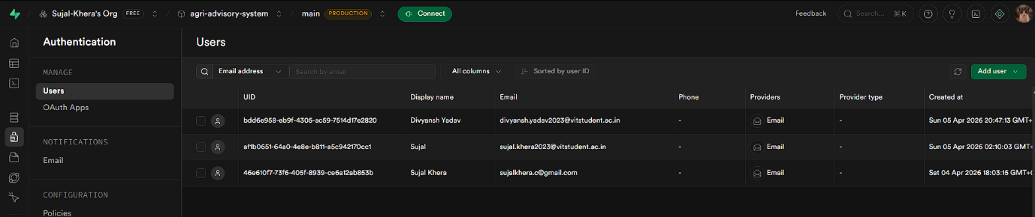

9. External API Integration
The backend integrates multiple external APIs for fetching environmental data and providing advisory services.
The OpenWeather API is used to fetch weather information including temperature, humidity, and rainfall.
The SoilGrids API is used to fetch soil characteristics based on location.
The Gemini API is used for generating advisory responses.
These APIs are integrated into backend services and used for advisory generation.
10. Backend Service Architecture
The backend services are organized into multiple modules. Each module handles a specific functionality.
The crop service handles crop recommendation model inference.
The disease service handles image based disease detection.
The weather service handles weather API requests.
The Gemini service handles advisory generation.
The Supabase service handles database operations.
This modular architecture ensures maintainability and scalability.
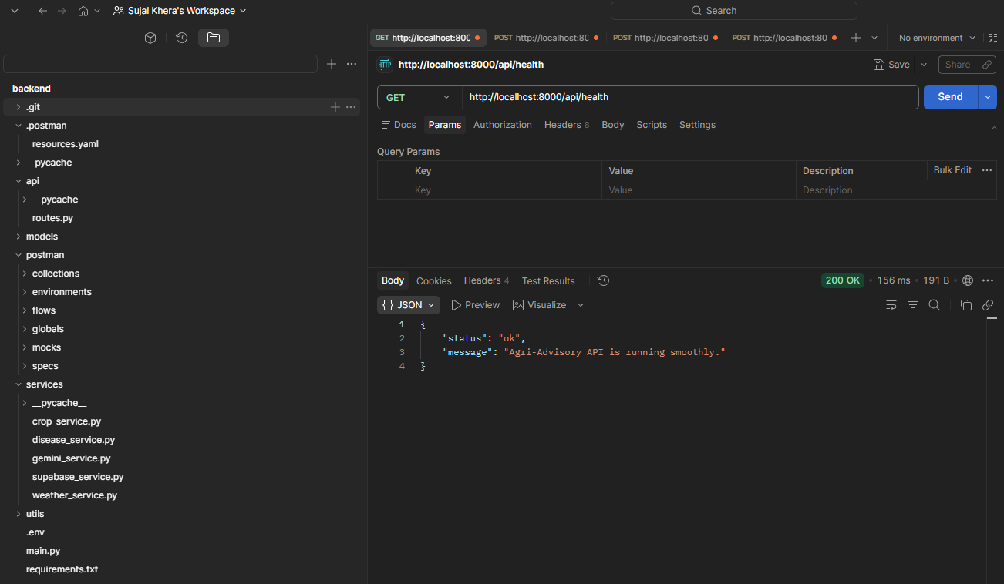
11. Implementation Status
The backend system has been successfully implemented. Machine learning models have been trained and deployed. APIs have been developed and tested. Database integration has been completed.
The backend services are operational and capable of handling inference requests. The system can predict crops, detect plant diseases, fetch weather data, and store results in database.
The frontend interface, price forecasting module, and RAG based advisory system are planned for future development.
12. Conclusion
The Intelligent Multimodal Agricultural Advisory System has achieved fifty percent implementation with successful backend development. Machine learning models, APIs, database integration, and external API connectivity have been implemented.
The backend infrastructure is functional and ready for frontend integration. This milestone represents a major step toward building a complete agricultural advisory system.
The next phase of development will focus on frontend integration, advisory pipeline enhancement, and additional model deployment.
This concludes the fifty percent backend implementation documentation.

50% implementation Video:
https://drive.google.com/drive/folders/1XbWEgX2FSJM8rI18uZE6fX1RbR2FS-V1?usp=sharing

